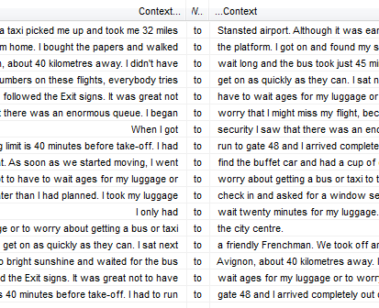
Direction
Modal have to
Verb+to (e.g. would like to…)
Adjective+to (e.g. It’s important to practice daily)
Reason (e.g. I closed my eyes to relax a little)

