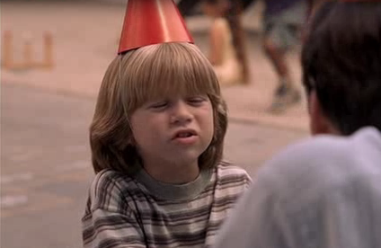 | PLAYGROUND | - You mustn't smoke on the playground.  - You mustn't leave your children unsupervised.  - You don't have to pay to use the playground. | What most annoys me is when people drop litter on the playground.  What really makes me angry is when parents are busy chatting with other parents while their unsupervised children make terrible noise or start a fight.
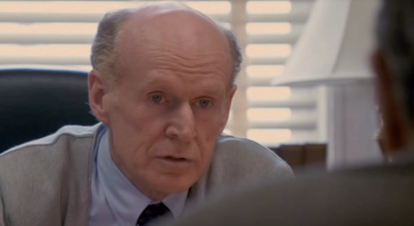 | DOCTOR’S OFFICE/  HOSPITAL | - You don’t have to make an appointment to see a doctor.  - You must keep quiet in the hospital. | What really annoys me is when you have to wait ages for your appointment.  I hate it when someone goes before you saying “I only have a quick question”. And you have been waiting in the queue for hours!
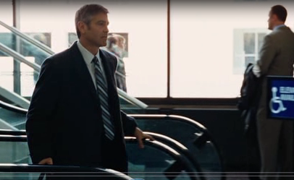 | AIRPORT | - You mustn't smoke in the airport, except for designated places.  - You have to check in large suitcases. | I hate it when there’s only one tiny smoking room on the entire floor and it hosts 20 people. It’s impossible to breath in or near this room.  What really makes me angry is when you have been queuing for check-in, and the check-in window suddenly closes without prior notification.
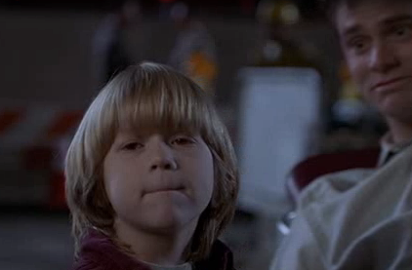 | RUNWAY | - You MUSTN’T BE on the runway  - You must follow the safety instructions if you happen to be on the runway. | What really annoys me is when the plane is ready for take-off but nothing happens, The passengers get worried but the pilot keeps silence.
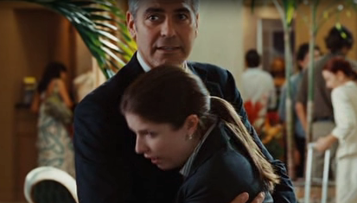 | HOTEL | - You must check out before 12.  - You should put a sign on your door when you want your room to be cleaned.  - You don't have to bring your own towel . | I hate it when you stay in a hotel on the same floor with a teen volleyball team.  What most annoys me are rude or indifferent receptioinists.
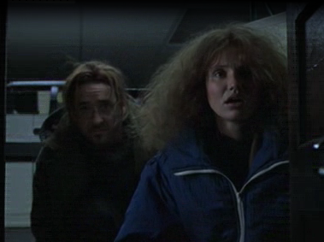 | OFFICE | - You must follow the dress code.  - You have to be on time.  - You shouldn’t argue with your boss. | What really makes me angry is when you are trying to concentrate and your colleagues are chatting and laughing loudly.  I hate it when the boss says the deadline was yesterday which means you have to stay in the office till midnight.

